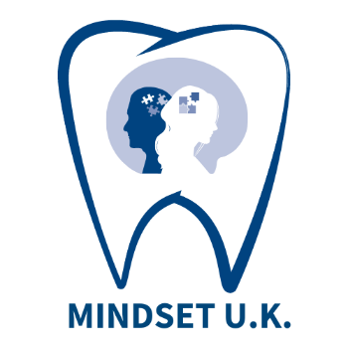

Mental health IN Dental SETtings U.K. Project
SURVEY 2023

You are being invited to take part in a UK wide survey to help inform the development of educational and service resources to support the mental health and wellbeing of dental teams. Before you decide if you would like to participate it is important that you read the information provided below. This will help you to understand why and how the survey is being carried out and what participation will involve.

- Who is conducting this survey?
The survey has been developed by the UK Dental Team Mental Health Research and Implementation Group, consisting of a range of experts from all four UK nations.
The Chief Investigators are:
Scotland: Jennifer Knights, NHS Education for Scotland (NES) jennifer.knights@nhs.scot
England: Professor Tim Newton, University of Kings College London tim.newton@kcl.ac.uk
Northern Ireland: Michael Donaldson, Health and Social Care Northern Ireland michael.donaldson@hscni.net
Wales: Dr Ilona Johnson, Public Health Wales ilona.johnson2@wales.nhs.uk

- What is the purpose of this survey?
The purpose of this survey is to evaluate current levels of burnout, depressed mood, experienced trauma and preparedness to provide quality care in dental teams in the UK. The questions asked are derived from widely-used and validated measurement scales. The findings will provide a snapshot of the mental health and wellbeing of dental teams across the UK and will inform the development of supportive educational and service resources.
- Why am I being invited to participate?
You have been invited to take part because you are a member of the dental team, working in a dental setting in England, Northern Ireland, Scotland or Wales.

- Do I have to take part?
No, participation is voluntary. You should only complete the questionnaire if you are happy to do so. If you do not wish to take part, you do not have to give a reason. Similarly, if you do agree to participate and then change your mind when completing the questionnaire, you can exit the questionnaire and any data you have entered will not be recorded.
- What am I being asked to do?
You are being asked to complete a single online questionnaire. Most of the questions ask you to select an option by clicking on a box. There is also a text box where you can give more detail about your answers if you wish. The questionnaire is anonymous, and it will not be possible to identify you from your answers. It will take approximately 5 to 10 minutes to complete.

- Are there any risks to taking part?
There are no known risks associated with taking part in this project. The measurement scales used are only meaningful in the context of a survey and cannot be used for clinical diagnostic purposes. If you wish to speak with someone about your mental health and wellbeing, please contact your doctor or NHS dedicated mental health support, (https://www.gov.uk/government/news/dedicated-mental-health-support-for-all-nhs-doctors-and-dentists). There are also various other charitable helplines (https://www.nhs.uk/conditions/stress-anxiety-depression/mental-health-helplines/).

- What are the benefits of taking part?
There are no tangible benefits for you personally. However, by taking part you will help to inform the development of educational and service support and training for all members of the dental team.

- What will happen to my responses if I participate?
The anonymous data you provide will be collected, managed and processed by the project team in NES. All data collected will be securely stored and accessed from the NES network.
All the information collected from the questionnaire is anonymous, no personally identifiable information will be gathered. Representative quotes provided in the free text box may be used to illustrate commonly identified themes. Data will be managed and processed in accordance with NHS Education for Scotland’s Privacy and Data Protection Notice. Data will be stored as per NHSScotland’s data retention policy and may be used in future projects.
- What will happen to the results of the survey?
The results of the survey will be shared with policy, service and education leaders in dentistry across the UK to inform the future provision of mental health and wellbeing support and training for dental teams. The findings may also be published peer reviewed journals and presented at relevant conferences. It will not be possible to identify you in any report or publication arising from this work.
If you have any questions about this work or would like to find out more, please contact
Jennifer Knights, Co-Chief Investigator for MINDSET U.K. at jennifer.knights@nhs.scot

Thank you. Your contribution is very much appreciated.

